# REQUIREMENTS MODELLING

## Context free diagram

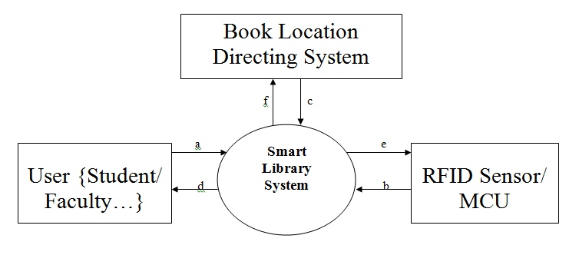

## USE CASE DIAGRAM



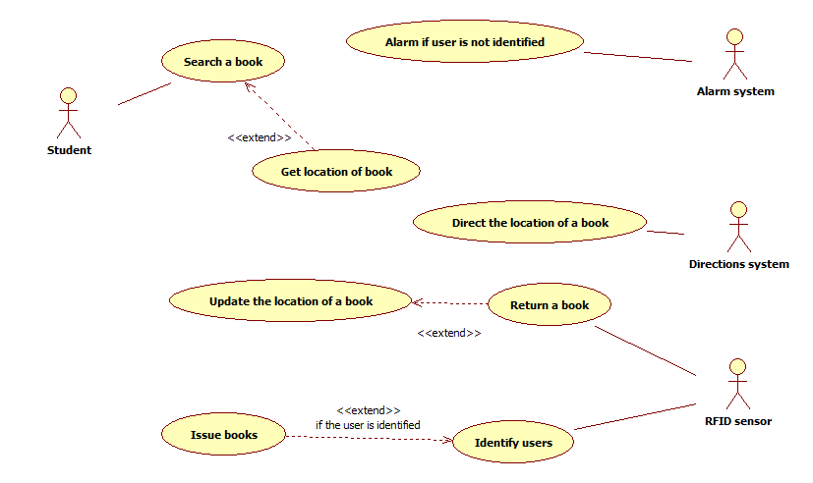

## Class diagram – Logical view

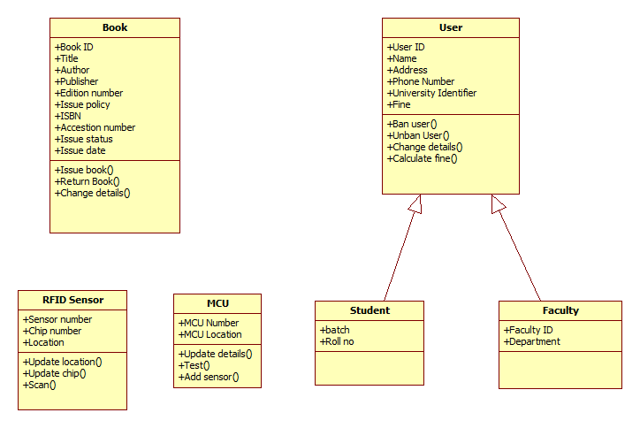

## Operating Environment

The product is designed to run in a webserver, supporting PHP scripting and a database management system like MySQL. The servers should provide a robust and fast environment for the product. It should cater the needs of its many users both faculty and users and support parallel access without any lag and avoid downtime.

These features are required in the webserver where the product is supposed to be hosted

* Servers with Top Line Hardware specs.
* Dedicated MySQL server to handle SQL Queries load.
* Remote weekly backups of server’s data for safety of data.